Space planning

How To!

Scenario

A final draft stand alone will be used as a guide, this stand alone was created in the store location and saved as a *.psa file. This will be guide that needs to be followed.

A POG that’s in WIP with identical products from the stand alone will be used.

Open the Stand alone *.psa file, open the WIP POG that’s in the database.

First thing that’s needed to do is ensure that the fixture shelves are identical, move, add, delete shelves as required.

Right click on the stand alone planogram’s shelves, identify the height copy/paste to the WIP POG.

Once all the shelves are setup properly like the stand alone shelves you’ll need to re-label the shelves.

From the current WIP POG, open table - new fixture name.pst

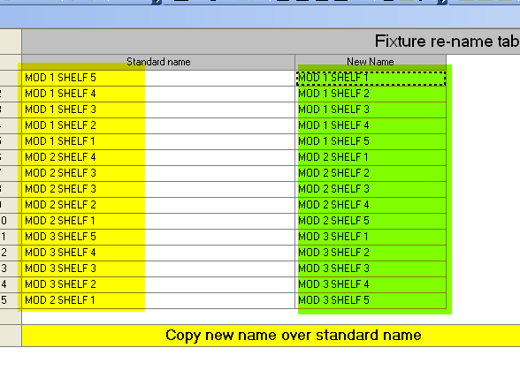 | Copy the New Name column to replace the Standard Name (current column name) column  This will re-label the shelves after you’ve added, deleted any shelf fixtures
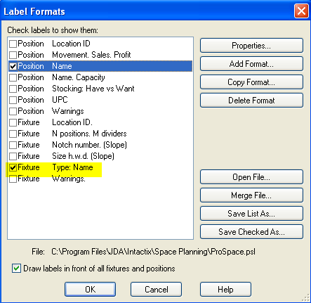 | To make the shelf labels appear and verify that they’ve been updated go to  Settings > Label Formats  And click on Fixture Type: Name
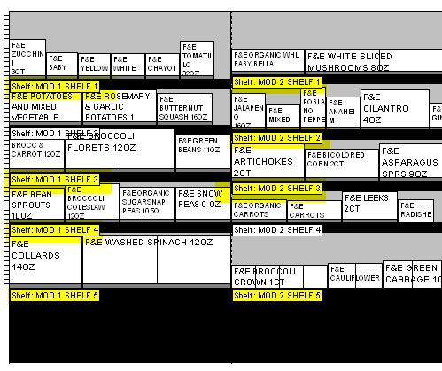

Warning Errors

When trying to move from WIP to ASO warnings would appear.

Ensure that all errors are identified and fixed before you can move from WIP to ASO

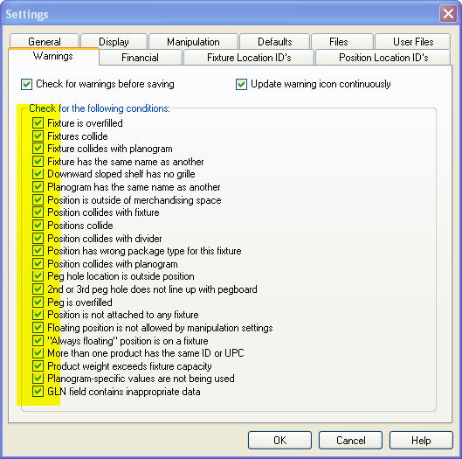 | Settings > GENERAL > WARNINGS tab  Ensure that all are selected
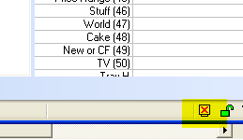 | Lower right hand of the window is a box showing that there are warnings in the POG  Check the box and it will identify the warnings in the POG
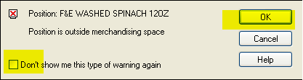 | After the warning box is clicked it will soon validate the POG  The warnings will appear, click on Don’t sow me this type of warning again and OK

Adjusting the shelves manually

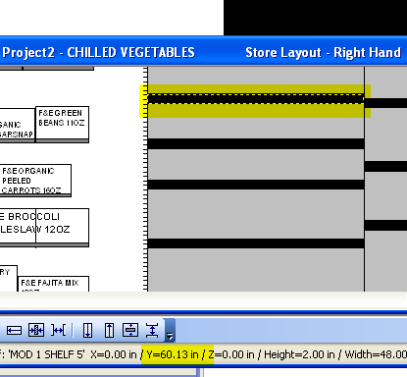 | Select the shelf  In the bottom it will show the Y coordinates
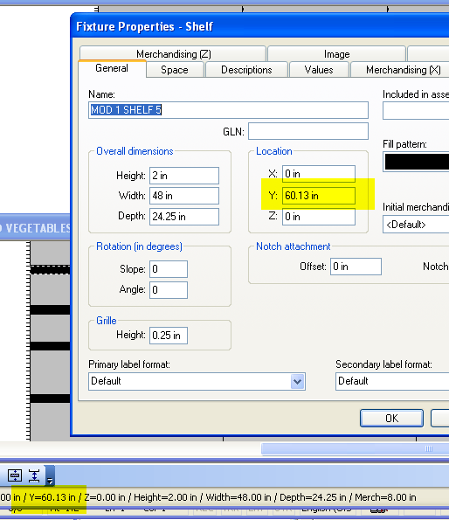 | Double clicking the fixture will pop up the fixture properties shelf  This is where you can modify the Y: coordinates for the shelf

